Review of Online Chinese Character Handwriting Recognition for Linux

Literature Review

Author: Ran Cheng
Student ID: n5105269
Course: IT29 - Honours of IT
Primary Supervisor: Jim Hogan
Associated Supervisor: Jinhai Cai
Subject: Research Methodology

Table of Content
1. Introduction 2
1.1 Problem definition 2
1.2 Content and Structure 2
2. Hidden Markov Model 3
2.1 Introduction 3
2.2 Element of an HMM 4
2.3 Three classic problems 4
2.4 Type of HMMs 5
3. Dynamic Programming (DP) 6
4. Chinese Character Processing 7
4.1 Introduction 7
4.2 Character segmentation 8
4.3 Pre-processing 8
4.4 Pattern Representation 9
4.5 Classification 9
4.6 Context processing 10
5. Conclusion 10
6. Reference 11

Introduction
Handwriting is one of the input methods to let user interact with computer. Handwriting recognition has been researched for many years, but until recent years, as new types of pen input devices and interfaces have been developed, some major hardware issues have been resolved, and handwriting started to be used in PC. As a sub-project of “Internationalisation of Software” which is sponsored by Redhat (a leading Linux company), in this project, we’ll try to develop a new algorithm for Chinese Character handwriting recognition under Linux.

Problem definition
Unlike English, Chinese language has more than 10,000 character categories, and more than 50,000 characters. So recognize Chinese character is much harder than recognize English. Chinese character is composed by strokes, and the order or position of the strokes have significant influence on the recognition. In some cases, two or more characters looks very similar, but they have large difference in terms of semantic meaning. Handwriting recognition for English has been researched for ages, but until recent years, handwriting recognition for Chinese started getting popular. Handwriting recognition is sort of pattern classification, for each character, we need some pattern to match. English language only consists of 26 different characters. Chinese language, however, consists of more than 50,000 different characters, even though the most common used characters are more than 1,000. So the pattern we need to recognize Chinese characters are far more difficult than English characters. There are some technologies and algorithms already exist, but most of them doesn’t do good job, in the other words, the quality of recognition are not good.

Several questions we try to resolve in this project are:
- Online Handwriting recognition and recognition accuracy
- Recognition for Chinese Character
- Implementation of handwriting recognition algorithm under Linux

Content and Structure
This document is a review of existing technologies and techniques of Online Chinese Character Handwriting recognition for Linux Operating System. By investigating the existing technologies and techniques, we try to adopt some useful features of them and develop a new algorithm on top of them.

This document contains three main sections: Hidden Markov Model, which describes some fundamental HMM stuff; Dynamic Programming, which gives some explanation of this compute science term; and finally, Chinese Character Processing, which discusses the existing research work and techniques have been done by previous researchers.

Hidden Markov Model

Introduction
HMM was initially introduced and studied in the late 1960s and early 1970s, and it’s kind of statistical methods of Markov Source. HMM is assumed to be a Markov process with unknown parameters, and the challenge is to determine the midden parameters from the observable parameters. The extracted model parameters can be used to perform further analysis, and one example is the pattern recognition application which is category our project belongs to. HMM differs from Markov model, because in Markov model, the state is directly visible to the observer, in the HMM, the state is hidden but the state can influence some variables which are visible. Each state has a probability distribution over the possible output observations, so the sequence of observations generated by an HMM gives some information about the sequence of states.(Wikipedia, 2006b) In our project, for the handwriting part, the stokes can be transformed into a sequence of dots, which can be treated as the observation sequence, and the final shape of the character can be treated as the state. Therefore, by observing the sequence of dots input by user, the system will guess the correct character. This is one of the main reasons we choose HMM, and the other two strong reasons the HMM draw our attention are: firstly, the models are very rich in mathematical structure and hence can from the theoretical basis for use in a wide range of applications; secondly, when the models are applied properly, it works well in practice for several important applications.(Rabiner, 1989)

Element of an HMM
An HMM is characterized by the following:
- N, the number of states in the model. As we mentioned in the introduction, the state is hidden in the models, but for many practical applications, the number of the state are known.
- M, the number of distinct observation symbols per state.
- The state transition probability distribution A = {a_{ij}}, where
The formula means the probability of changing state from S_{i} at time i to S_{j} at time j.
- The observation symbol probability distribution in state j, B={b_{j}(k)}
- The initial state distribution π.

Given appropriate values of N, M, A, B and π, the HMM can be used as a generator to give an observation sequence.

Three classic problems
Problem 1: Given the observation sequence and a model, how to efficiently compute the probability of the observation sequence, given the model?
Problem 2: Give the observation sequence and the model, how to choose a corresponding state sequence whch is optimal in some meaningful sense?
Problem 3: How to adjust the model parameters to maximize the probability of the observation sequence.

We don’t want to worry about how to get the solution to those problems; instead of we want to discuss the implication of the problem and how we can use those solutions to resolve problems.

Problem 1 is the evaluation problem. This problem can be treated as one of scoring how well a given model matches a given observation sequence. In other words, problem 1 allows us to choose the model which best matches the observations.

Problem 2 is trying to uncover the hidden part of the model – state. One thing we should pay attention is that we can’t really find the “correct” state sequence. All we can do is to find out the best or optimal state sequence. Normally, there are several reasonable optimality criteria that can be imposed, and hence the choice of criterion is a strong function of the intended use for the uncovered state sequence. For our project, we’ll be using the theory listed in this problem. By observing the observation sequence, the system will try to find out all the possible states (characters) and list the top 10 or whatever number we required.

Problem 3 can be viewed as a “training” problem. The observation sequence used to adjust the model parameter is called a training sequence since it is used to “train” the HMM. The training process will be essential part of our project. For our project, after developing the recognition system, we need train it, and we need let it be able to recognize the template for each character.

Type of HMMs
There are two main types of HMMs and there are many possible variation and combinations possible. The first main type of HMM is called ergodic model, in which every state can be reached from ever other state in a finite number of steps. This kind of HMM is most common used in the practice. The seconde main type of HMM is called left-right model or a Bakis model. In this kind of model, the state sequence has the property that as time increases the state index increases. We use the following two pictures to show the underlying structure of these two models.
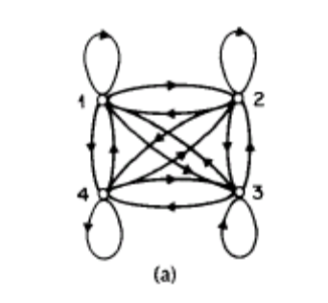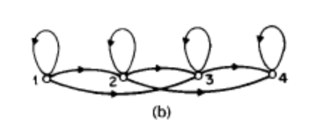
We can see from pic (a), all the states are connected with each other, and the arrows indicate the communication directions are enabled. In pic (b), at any time, the current state can only communicate with the following states and itself, but no previous state can be reached.

The left-right model are particular useful for our project, because this kind of model has “the desirable property that it can readily model signals whose properties change over time” (Rabiner, 1989), like speech and handwriting.

Dynamic Programming (DP)
“In computer science, dynamic programming is a method for reducing the runtime of algorithms exhibiting the properties of overlapping subproblems and optimal substructure, described below.”(Wikipedia, 2006a)

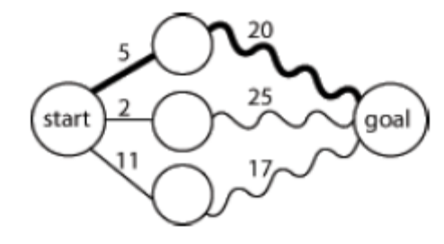
Optimal substructure means that optimal solutions of subproblems can be used to find the optimal solutions of the overall problem. We use the picture shown left to explain the definition. Starting from the leftmost circle, we got three paths to reach the rightmost circle. The number between near the line means the distances. By observing the picture, we can see at the middle of the overall path, the second path from the top has the shortest distance, however, in terms of the total distance, the top path is the shortest. Although the second path was leading the way at some point, the optimal solution is the top path.

Normally, three-step process we should take is:
Firstly, break the problem into smaller subproblems.
Secondly, solve these problems optimally using this three-step process recursively.
Thirdly, use these optimal solutions to construct an optimal solution for the original problem.(Wikipedia, 2006a)

Overlapping subproblems mean that the same subproblems are used to solve many different larger problems. We take Fibonacci sequence as example, F3 = F1 + F2 and F4 = F3 + F2, the consequence calculation also include F2. The calculation of F2 is involved in each following calculations. So we say F2 is the overlapping subproblem in Fibonacci sequence.

The overlapping subproblem introduced a new problem to us. In each calculation of Fibonacci sequence, the calculation may end up computing F2 twice or more. In this approach, it may waste time recomputing optimal solutions to subproblems the system has already solved. To avoid this, the memoization approach was introduced. Memoization means that if the same problem may be need to resolve later, the system will save the solutions to the problem and retrieve and reuse the solutions.

DP usually takes one of two approaches:
Top-down approach: break the problem into subproblems, and after resolve these subproblems, recombine all the subproblems back together.
Bottom-up approach: resolve all the subproblems in advance and then use them to build up solutions to larger problems.

DP can be very useful in the character recognition processing. Picture shown below simulate DP in Chinese Character recognition. As the new strokes are added in, the possibilities of the character change over time, eventually, the system will optimize all the possible solutions and find the best fit one.
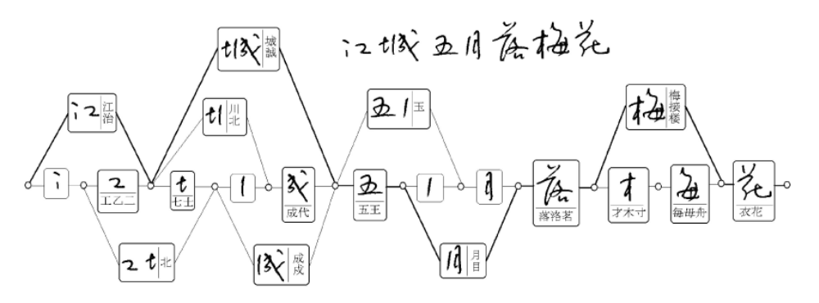

Chinese Character Processing

Introduction
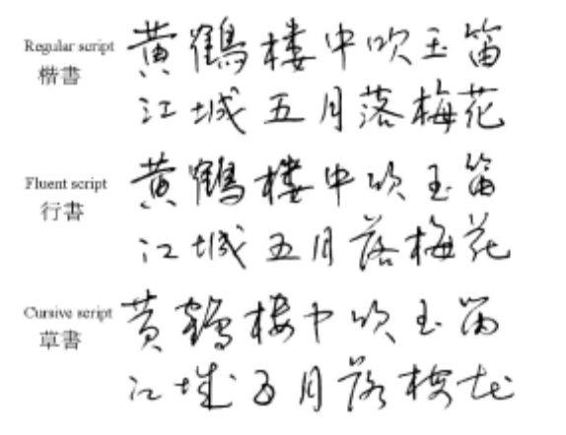
More than one quarter of world’s population use Chinese characters in daily communications. There are three main types of Chinese characters: simplified Chinese characters, which are used in mainland China and Singapore; traditional Chinese characters, which are used in Taiwan, Hong Kong and Macao; and Japanese Kanji, which are used in Japan. In both traditional and simplified Chinese, about 5,000 characters are frequently used, In Kanji, 2,965 Kanji characters are included in the JIS level 1 and 3,390 characters in level 2.(Liu, Jaeger, & Nakagawa, 2004) Although there are a lot of styles of Chinese Characters, normally, the most common used three styles are regular script, fluent script and cursive script. Picture on the right-hand side show the difference between these styles.

Character segmentation
When the handwriting sequence is input into the system, no matter what kind of types of Chinese characters or styles they are, the sequence should be segmented into character patterns according to the temporal and shape information. Frequently, the boundary between characters can’t be determined unambiguously before character recognition, so a set of candidate character patterns are selected in contextual processing at the end of the process chain. After the segmentation, a set of individual Chinese character are output to next stage. Although there is a lot of research work has been done separately, a lot of recognition approaches are available, but for the segmentation part, almost all researchers follow the same pattern.

Pre-processing
Pre-processing consists of noise elimination, data reduction, and shape normalizations. The common used noise reduction techniques are smoothing, filtering, wild point correction, stroke connection, etc.(Tappert, Suen, & Wakahara, 1990) As the quality of input devices is getting mutual and better, trajectory noise becomes less influential and simple smoothing operations will suffice.(Liu et al., 2004)

Two frequently used approaches for data reduction are equidistance sampling and line approximation. With equidistance sampling, the trajectory points are resampled such that the distance between adjacent points is approximately equal. Line approximation, also called feature point detection, is often used in many online recognition systems.

Normalization of character trajectories to a standard size is adopted in almost every recognition system, so will our project. Three main approaches for normalization are linear, moment and nonlinear normalization. Linear normalization means that the coordinates of stroke points are shifted and scaled such that all points are enclosed in a standard box. Moment normalization means that the centroid of input pattern is shifted to the centre of standard box and the second-order moments are scaled to a standard value.(R.G.Casey, 1970) Nonlinear normalization means that the coordinates of stroke points according to the line density distribution with the aim of equalizing the stroke spacing.(S.-W., Lee, & Park, 1994)

Pattern Representation
The representation schemes of input pattern and model database are of particular importance since the classification method depends largely on them. The representation schema can be divided into three groups: statistical, structural, and hybrid statistical structural. In statistical representation, the input pattern is described by a feature vector, while the model database contains the classification parameters. The statistical-structural scheme is only used for describing he reference models. It takes the same structure as the traditional structural representation, yet the structure elements and/or relationships are measured probabilistically. HMM can be regarded as instances of the statistical-structure representation.

Pattern Representation and the following section – Classification will be the main area we are going to focus on in our project. We’ll be trying to apply HMM to the new algorithm.

Classification
Classification is the core of almost every recognition system. Classification can be further divided into coarse classification and fine classification. Coarse classification can be accomplished by class set partitioning or dynamic candidate selection. In class set partitioning, the groups of classes are determined in the classifier design stage using clustering or prior knowledge. Class grouping can be based on overall character(C. K. Lin & Fan, 1994), basic stroke substructure(R. H. Chen, Lee, & Chen, 1994), stroke sequence(Z. Chen, Lee, & Cheng, 1996), and statistical or neural classification(Matic, Platt, & Wang, 2002). In dynamic candidate selection, a matching score is computed between the input pattern and each class and a subset of classes with high scores is selected for details classification.

In fine classification, three common used approaches are Structural Matching, Probabilistic Matching and Statistical Classification. Structural matching means the input pattern is matched with the structural model of each (candidate) class and the class with the minimum matching distance is taken as the recognition result. Probabilistic matching means that using probabilistic attributes in representing structural models and computing matching distance. Statistical classification means that using various statistical techniques for classification when describing the input pattern as a feature vector.(Liu et al., 2004)

Context processing
The linguistic context can provide valuable information for selecting the optimal class from this set of candidates. In addition, the geometric features of character patterns are useful to segment a handwriting sequence into single characters. Based on the candidate classes given by the character recognizer, additional candidates can be added according to the statistics of confusion between characters in order to reduce the risk of excluding the true class. The selection of final class from candidate class is based on the linguistic knowledge represented in word dictionaries, character-based n-grams, or word-based n-grams.(M.-Y. Lin & W.-H.Tsai, 1988) Some locale specific dictionary can be used to help to determine the optimal solutions. The ambiguities in segmentation are generally solved by generating candidate character patterns and verifying the candidate patterns using geometric features, recognition results, and linguistic knowledge.

Conclusion
The purpose of this literature review was to look at the field of Online Chinese Character Handwriting recognition. It has shown that there are many different techniques, approaches and algorithms developed to apply handwriting recognition to Chinese Character.

Many have been successful, but even so, the fact that there are many different approaches and papers written show that there is still work to be done. There is no single best algorithm, which exactly fix our research project, so we need a customised approach to help us resolve our research problem.

This review has demonstrated that there is still much work to be done in the field of Online Chinese Character Recognition, especially for Linux OS, which is exactly what we are going to focus on.

Reference

